MEMORANDUM Date: January 31, 2006

From: David M. Chambers

To: Bristol Bay Alliance

Re: Notes on Geochemical Characterization of Rocks from the Pebble Mine

I have been provided with a copy of the document “Draft Environmental Baseline Studies 2004 Progress Reports, Chapter 8, Geochemical Characterization & Metals Leaching/Acid Rock Drainage,” Northern Dynasty Mines, Inc., June 2005.
This is evidently a Northern Dynasty Mines’ description of some of the work being overseen by Linda Broughton and Stephen Day, both well known geochemical consultants specializing in Acid Rock Drainage. Probably because it is not written by Broughton/Day, it lacks precise descriptions of the results of the studies. I will describe what I can glean from the report, as well as what I can’t tell:
Samples for Acid Rock Drainage
A total of 399 samples from 65 different drill holes were collected, all from holes drilled in the period 1988 – 2003. Samples appear to have chosen based on the different types of rock in the Pebble deposit, as opposed to distinguishing between waste and ore, which I assume will be done at some later date.
These samples were analyzed for sulfur content (acid generation potential) and neutralizing potential (which is generally related to calcium carbonate content). Most regulatory agencies consider rock with a ratio of three times as much neutralizing material to acid generating material to be non-acid generating. Rock with equal amounts of neutralizing and acid-generating material, or with more acid-generating material than neutralizing material, are considered acid generating. If the analyses falls between these ranges (3:1 and 1:1), then the rock is considered to be potentially acid-generating.
The figure on the next page (FIGURE 5), taken from the Northern Dynasty report, shows a plot of Neutralization Potential (NP) versus Acid Potential (AP) for the 399 samples. Each data point corresponds to one of the 399 samples tested. The solid lines on the graph represent constant rations of NP:AP for the rations of NP:AP = 2:1 and NP:AP = 1:1.
Many industry scientists consider rack with an NP:AP ratio of 2:1 to be non-acid generating, which is why this graph does not present the more conservative NP:AP = 3:1 line which regulatory agencies would use.
However, regardless of technical merits of using a ration of NP:AP = 2:1 or 3:1, it can clearly be seen from FIGURE 5 that most of the 399 samples lie below the NP:AP = 1:1 line – that is, they are in the acid-generating category, not the non-generating or potentially acid-generating.
These samples were also used to start Humidity Cell tests, where rock samples are placed in cells (usually PVC tubes) and exposed to air and water over a long period of time. Water samples are taken after water has been dripped through these test cells to determine what metals and other oxidation products are leaching from the rock in the cells. Data was not available/presented from these tests.
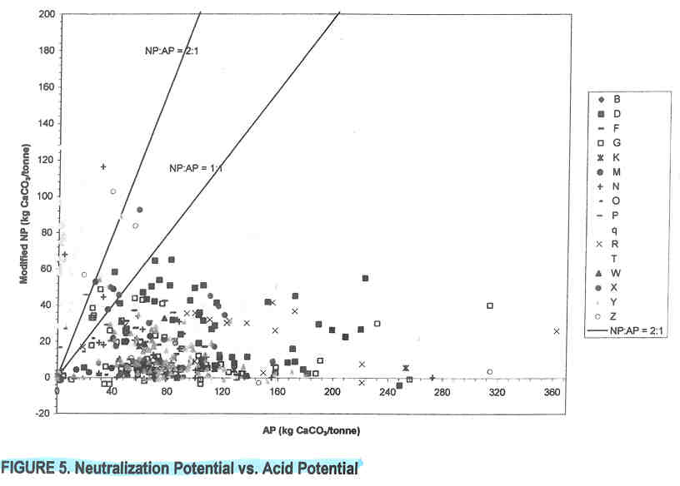
Several other conclusions were drawn from this data analysis in the report (although the underlying data was not presented or discussed by NDM), they include:
- “… sulfur occurs primarily as sulfide minerals.” (rather than as sulfate minerals, which would not pose risks for acid generation)
- “Sulfur concentrations in the pre-Tertiary rock types (i.e. much of the ore and non-overburden waste) are typically between 1 and 5 percent sulfur up to maximum concentrations near 9 percent.” (1% – 5% sulfur-as-sulfides is typically in the range for concern for acid mine drainage)
- “Evidence that oxidation (of core samples) has occurred in storage is illustrated by the general increase in sulfate sulfur relative to sulfur as the age of the core increased.” (this says that some acid rock drainage has occurred in the older core samples taken from the site)
- “… preliminary calculations indicate that it would take about 40 years for nearly all pre-Tertiary rock to become acidic under site conditions.”
Characterization of Metallurgical Waste Products
The mine will produce several types of waste. These are:
(1) Waste Rock (2 types)
- Unmineralized overburden (a minority of the waste rock – quantities not given)
- Mineralized waste taken from in and around the ore body (most of the waste rock)
(2) Tailings (the waste remaining after ore has been processed to produce a mineral concentrate)
- Scavenger Tails & Bulk Cleaner Tails (non-acid generating)
- Pyrite Tails (produced by taking pyrite out of the Scavenger & Bulk Cleaner Tails – acid generating)
Pit Wall Sulfur Analysis
An “element scan” (not described) was conducted on samples collected from drill holes in the projected pit walls (2004).
Three holes were drilled in each the South, Northwest, an East walls of the projected 2004 pit walls. The pit would be flooded, leaving part of the pit walls exposed to air after closure.
The results of these scans indicate that the levels of sulfur above the projected water line of the pit lake are significant for:
- South Wall -- 2 of 3 drill holes, for less than 100 vertical feet
- Northwest Wall -- 2 of 3 drill holes, for 100 feet
- East Wall -- 0 of 3 holes
Preliminary Conclusions
The information presented in this report is not conclusive, especially in light of probably expansion of the proposed mine that will be based on the drill information taken in 2004 – 2006, information that was not available when this report was written. However, it is clear from the report that a good part of the rock from the mine will be potentially acid generating, and that great care will have to taken in designing a mine to mitigate this potential.

#####

