MERCURY IN ALASKA

Old Mercury Mines

Alaska contains numerous deposits of mercury scattered throughout the southwestern part of the state and several large abandoned mercury mines. These include the Red Devil, Cinnabar Creek, and Red Top mercury mines. Though mining has ceased, this area produced 41,000 flasks of mercury from the early 1900’s through the 1970’s.

The location of these abandoned mines and deposits are illustrated in the figure below.

Most of these deposits are concentrated in the southwestern region of the state, with the majority located in the Kuskokwim river basin, an area that is predominately Alaska Native and used as subsistence hunting grounds and fisheries. This area is also known for its gold deposits, as mercury is often associated with deposits of gold.

According to a report by Gregg Jones and Glenn Miller mercury concentrations in gold ore range from 0.1 to over 100 parts per million (ppm).

Tests conducted by the USGS show that mercury contamination has occurred in the water surrounding the abandoned mercury mines of the Kuskokwim River Basin. This is likely a result of naturally occurring mercury and mercury liberated during mining activities. Though mercury concentrations in the waterways surrounding the mine do not exceed guidelines set and by the State of Alaska and the US EPA, samples do indicate the mercury concentrations exceed those determined by the EPA to result in chronic effects to aquatic life. Data from the USGS and the Alaska Division of Environmental Conservation note mercury concentrations exceeding the EPA recommended oral exposure limit in several common sport fish.

Despite these findings, the State of Alaska Division of Public Health still recommends unlimited consumption of Alaska’s fish for all. However data from Alaska’s voluntary mercury hair bio-monitoring program show that among those tested all women who exceeded the limit requiring follow-up testing were from the Kuskokwim River Basin.

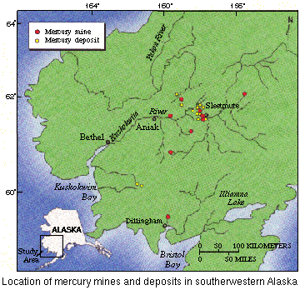

Source: United States Geological Survey

Jones, Gregg and Glenn Miller. Mercury and Modern Gold Mining in Nevada. Final Report to US Environmental Protection Agency Region IX. University of Nevada, Reno NV. Submitted October 24th, 2005.
http://pubs.usgs.gov/fs/fs-0072-94/
Alaska Department of Environmental Conservation Fish Monitoring Program Top Heavy Metal Concentrations (ppm) for Fish Species Collected: Update January 2007
State of Alaska Department of Epidemiology. Bulletin: Alaska Mercury Bimonitoring Update, July 2002- December 2006. No 4. February 26, 2007
Ibid

